The Plasma Experiment

Stephen O’Shea, Caoilainn O’Regan
13321762

Abstract

In this experiment, various properties of argon gas and plasma were investigated. In the first portion an argon gas tube was used to attempt to find values for the electron charge to mass ratio e/m and the ionisation potential of argon, which were found in the experiment to be 3.96x10¹¹ C kg⁻¹ +- 0.54x10¹¹ C kg⁻¹ and 16.8 V +- 0.5V respectively, compared to their known values of
1.759x10¹¹ C kg⁻¹ and 15.6V. In the second portion, an argon plasma was generated in a different gas tube, and it’s properties diagnosed with a Langmuir probe. The electron plasma temperature was found to be 0.7916eV +- 0.0124eV, and the electron density was found to be 1.74x10¹⁶ m⁻³ +- 4.2x10¹⁵ m^{-3.}

Introduction

Plasma was first discovered by William Crookes in 1879, though not called ‘plasma’ until much later. A plasma is essentially a gas consisting of charged particles, electrons and ions, rather than neutral atoms or molecules.¹ As a whole, plasmas tend to be electrically neutral, as appreciable deviations from neutrality will produce large potentials which cause the charged particles to move such as to reduce these potentials, back towards neutrality.²

This experiment is divided into two parts, which will be discussed separately

Experiment 1: Measurement of e/m and ionisation potential of argon

Using an argon gas filled tube, the goal of this experiment is to find a value for e/m for an electron, it’s charge to mass ratio, as well as the ionisation potential of argon. To find e/m we make use of the Child-Langmuir law for the given geometry of the tube (cylindrical electrode), which is given by
(1)
where I is the measured current in the tube, ε₀ is the permittivity of free space, L is the anode length, R is the anode radius, e is the electron charge, m is the electron mass, and V is the collector voltage. By altering the voltage and measuring the corresponding current change in the tube, we can thus determine the value of e/m for the electron, as all other quantities would be known. This law only remains true for low voltages, as eventually as voltage increases, it will reach the point where it becomes possible for the potential to ionise the argon gas. The difference between this breakdown voltage, and the voltage when I=0, gives us the ionisation potential of the gas in question. The value of voltage at I=0 can be calculated from the plot generated from the data measured.

Experiment 2: Measurement of the plasma electron density and electron temperature using a Langmuir probe

Using a different tube, containing argon gas and a triode, the plasma electron temperature and electron density and will be found in this experiment. To find the electron temperature, we can use the relation
(2)
where I is the measured current, e the electron charge, V the measured voltage, k the Boltzmann constant and T_{e} the plasma electron temperature. By altering the probe voltage and measuring the corresponding current change, a value can be found for the plasma electron temperature. This relation only applies for low voltage, as at higher (absolute) values of voltage, the behaviour is different. As it increases into the larger positive values of voltage, the current measured is expected to saturate, at a value given by the equation

(3)
where I_{e} is the saturation current, A is the surface area of the probe (a cylinder), n_{e} the density of electrons, e the charge on the electron, k the Boltzmann constant, T_{e} the plasma electron temperature, and m is the mass of the electron.

Experimental Method

Experiment 1

Firstly, the circuit should be set up as in Diagram 1 (Appendix). The tube should be given some time, around 5 minutes, to warm up, before taking any measurements. Once heated up, the voltage from PS 1 should be increased in 0.5V increments, from 0 to around 17V. Then, the recorded V can be plotted against corresponding I^{2/3} values. This plot should be roughly linear, though care might need to be taken to expunge the values which occur past the breakdown voltage, as they can negatively impact the accuracy of a fit to the curve. This value of slope can then be used in equation 1, to find a value for e/m. Using the fit to the data points, the intercept with the y-axis of the plot can be acquired, i.e. the value of the voltage where I=0. In addition, the breakdown voltage can be estimated visually from the plot, and by subtracting the voltage at I=0 value from this, the ionisation potential of the gas, in this case argon, can be estimated.

Experiment 2

Firstly, the circuit should be set up as in Diagram 2 (Appendix). Once set up, the discharge voltage should be increased slowly, until a glow is visible from the tube, and once this has been observed, adjusted further to give a discharge current of roughly 10mA. Once complete, the measurements can begin to be taken; the probe voltage should be altered from -9V through to +15V, while measuring the probe current at each step, with use of varied step sizes, taking care to use smaller step sizes in regions where there is rapid change in recorded current with changing voltage. Once the measurements have been taken, the data can be plotted. In order to get a value for the plasma electron temperature, a plot of log(I) vs V should be constructed, focusing on the region of the data around zero bias, where there should be a large variation in current with respect to the voltage. This plot should be linear, the slope of which can be inserted into equation 2 to give a value for T_{e}. From a standard plot of the full dataset, it should then be possible to visually estimate the saturation current I_{e}, which can be used in equation 3 to give a value for n_{e}, the electron density.

Results and Analysis

Experiment 1

After recording all data (full dataset in Appendix Table 1), the following plots were produced in Python;
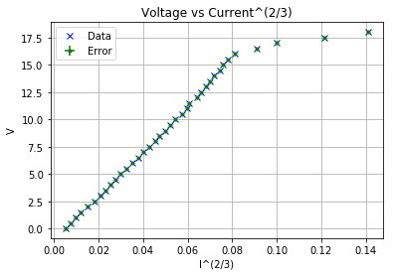

Figure 1: Full dataset plot, illustrating the linear relationship between Voltage and Current up to a breakpoint, where the relationship breaks down

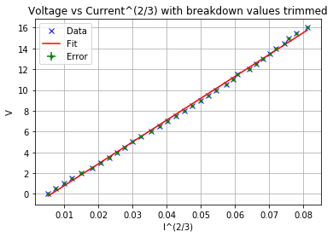

Figure 2: The dataset with post-breakdown values trimmed off, to allow for a more accurate linear fit

An immediate item to note in general is the accuracy of the equipment used, which contributes to the error in the recorded values being essentially not visible in the above plots, though they can be seen in a zoomed in version of the plot, provided in the Appendix (Figure A1).

With the data fitted, the desired quantities can thus be calculated. By inserting the slope of the linear fit into equation 1, we are able to find a value for e/m, which in this case was calculated to be 3.96x10¹¹ C kg⁻¹ +- 0.54x10¹¹ C kg⁻¹. Given that the known value for this quantity is
1.759x10¹¹ C kg⁻¹, this is not a particularly great result, being off by a factor of ~2.
From Figure 1, I estimated the breakdown voltage to be 15.5V +- 0.5V, which combined with the estimate for the intercept from the fitted plot of -1.3 V +- 0.07 V, gives an estimated ionisation potential of argon of 16.8V +- 0.5 V. This deviates from the accepted value of this property, known to be about 15.6 V ³, by about 7%.

Experiment 2

After recording all data (see Appendix Table 2) the following plot was produced in Python
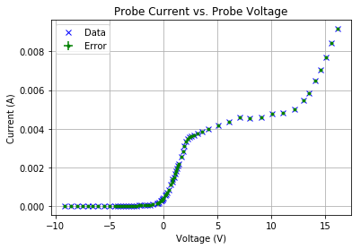

Figure 3: Full dataset plot, illustrating the various zones with different behaviours as voltage is varied

In the plot, there are several areas we are interested in, for example the area around 0 bias, from which we can determine the plasma electron temperature, using a plot of log(I) vs V in this area, which can be seen in Figures 4 and 5 below.

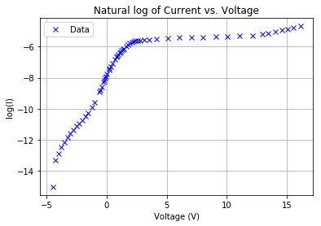

Figure 4: Showing the dataset with the log taken of the I values, with some of the values excluded due to having negative current

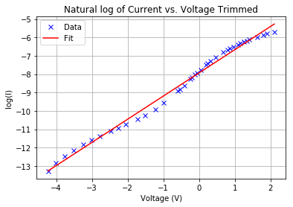

Figure 5: The dataset trimmed again to just the linear are around zero bias, to allow for a linear fit to be taken

Using the slope of this plot, equation 2 can be used to find the electron temperature, which was found to be 9186.038K +-144.405K, or 0.7916eV +- 0.0124eV. Based on Figure 3 and the data gathered, I estimated the saturation current I_{e} to be approximately 0.0047A, and using this and the value for the plasma electron temperature, the electron density can be found, using equation 3. This was calculated to be 1.74x10¹⁶ m⁻³ +- 4.2x10¹⁵ m⁻³.

Appendix

Diagram 1: Circuit diagram for experiment 1
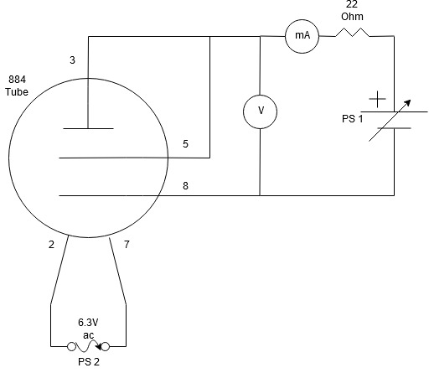

Diagram 2: Circuit diagram for experiment 2

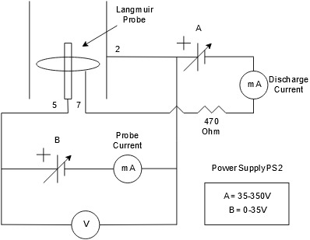

Table 1 - Experiment 1 Full Dataset

Voltage (V) | Voltage (V) | Current (A) | Current (A)
0.033 | 8.97 | 0.374e-3 | 11.16e-3
0.490 | 9.50 | 0.646e-3 | 11.93e-3
1.000 | 10.00 | 0.980e-3 | 12.72e-3
1.490 | 10.50 | 1.320e-3 | 13.74e-3
2.00 | 11.00 | 1.840e-3 | 14.53e-3
2.50 | 11.50 | 2.43e-3 | 14.98e-3
3.00 | 12.00 | 2.98e-3 | 16.31e-3
3.50 | 12.50 | 3.53e-3 | 17.03e-3
4.00 | 13.00 | 4.04e-3 | 17.80e-3
4.50 | 13.50 | 4.59e-3 | 18.60e-3
5.00 | 14.00 | 5.19e-3 | 19.28e-3
5.50 | 14.50 | 5.84e-3 | 20.3e-3
6.00 | 15.00 | 6.65e-3 | 20.8e-3
6.50 | 15.49 | 7.38e-3 | 21.8e-3
7.00 | 16.00 | 8.08e-3 | 23.1e-3
7.50 | 16.50 | 8.80e-3 | 27.4e-3
8.00 | 17.00 | 9.63e-3 | 31.6e-3
8.50 | 17.49 | 10.34e-3 | 42.4e-3
 | 18.00 |  | 52.9e-3

Table 2 - Experiment 2 Full Dataset

Voltage (V) | Voltage (V) | Current (A) | Current (A)
-9.15 | 0.672 | -2.1e-6 | 843e-6
-8.55 | 0.798 | -2.0e-6 | 1111e-6
-8.00 | 0.866 | -1.9e-6 | 1265e-6
-7.47 | 0.959 | -1.8e-6 | 1364e-6
-6.96 | 1.089 | -1.5e-6 | 1495e-6
-6.54 | 1.156 | -1.8e-6 | 1683e-6
-6.07 | 1.259 | -1.5e-6 | 1784e-6
-5.46 | 1.334 | -1.6e-6 | 1943e-6
-4.95 | 1.409 | -1.2e-6 | 2.06e-3
-4.49 | 1.628 | -0.6e-6 | 2.18e-3
-4.23 | 1.790 | 0.3e-6 | 2.53e-3
-4.01 | 1.908 | 1.7e-6 | 2.82e-3
-3.77 | 2.11 | 2.6e-6 | 3.10e-3
-3.52 | 2.26 | 3.8e-6 | 3.34e-3
-3.24 | 2.39 | 5.3e-6 | 3.46e-3
-3.01 | 2.58 | 7.3e-6 | 3.55e-3
-2.78 | 2.79 | 9.2e-6 | 3.62e-3
-2.47 | 3.12 | 11.4e-6 | 3.66e-3
-2.26 | 3.56 | 14.9e-6 | 3.74e-3
-2.05 | 4.14 | 17.9e-6 | 3.84e-3
-1.73 | 5.09 | 21.4e-6 | 3.97e-3
-1.52 | 6.06 | 28.7e-6 | 4.18e-3
-1.23 | 7.06 | 35.3e-6 | 4.36e-3
-0.99 | 7.98 | 49.8e-6 | 4.58e-3
-0.588 | 9.07 | 70.0e-6 | 4.52e-3
-0.537 | 10.06 | 134.2e-6 | 4.61e-3
-0.417 | 11.04 | 147.1e-6 | 4.77e-3
-0.238 | 12.12 | 182.2e-6 | 4.83e-3
-0.198 | 12.98 | 256e-6 | 5.02e-3
-0.121 | 13.46 | 276e-6 | 5.46e-3
-0.048 | 14.07 | 325e-6 | 5.86e-3
0.040 | 14.55 | 364e-6 | 6.47e-3
0.188 | 15.06 | 427e-6 | 7.06e-3
0.239 | 15.51 | 553e-6 | 7.71e-3
0.323 | 16.13 | 603e-6 | 8.44e-3
0.468 |  | 681e-6

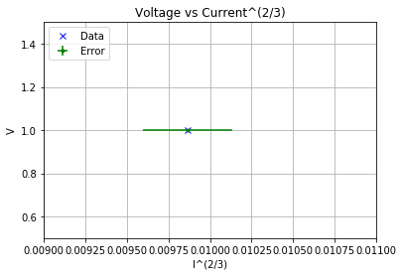

Figure A1: Showing the existence of the errorbars on a zoomed in plot

References

1. Cairns, R.A. Plasma Physics (1985) Section 1.1 [Online]. Available in part: https://books.google.ie/books/about/Plasma_Physics.html?id=-3agBwAAQBAJ&printsec=frontcover&source=kp_read_button&redir_esc=y#v=onepage&q&f=false

2. Spitzer, L. Physics of Fully Ionized Gases, Second Revised Edition (1962) pp. 21 [Online]. Available in part: https://books.google.ie/books/about/Physics_of_Fully_Ionized_Gases.html?id=sVDCAgAAQBAJ&printsec=frontcover&source=kp_read_button&redir_esc=y#v=onepage&q&f=false

3. Found C.G., Ionization Potentials of Argon, Nitrogen, Carbon Monoxide, Helium, Hydrogen and Mercury and Iodine Vapors (1920) Phys. Rev. 16, 41

